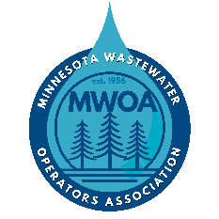

VENDOR/EXHIBITOR OPPORTUNITY
43rd ANNUAL INNOVATIVE APPROACHES TO WASTEWATER OPERATIONS CONFERENCE
Dear Potential Vendor/Exhibitor,
At the 43rd annual “Innovative Approaches to Wastewater Operations Conference”, we will be having an exhibitor hall which gives vendors an opportunity to showcase their company. The conference will be held February 10, 2026 at the River’s Edge Convention Center in St. Cloud, Minnesota. This conference is co-sponsored by the Minnesota Wastewater Operators Association and the Minnesota Section of the Central States Water Environment Association. These are two non-profit organizations dedicated to providing opportunities for educational growth to its members.
The fee for one booth space is $450, and includes the following –
- 8’x8’ booth space
- 2 registrations to the conference (lunch included)
- 1-2 minutes on stage to present your new and innovative products
- Ability to attend conference sessions with the conference participants
Registration and payment should be completed by January 28, 2026. Online registration is available at https://www.cswea.org/upcoming_events.php. Exhibitors are accepted on a first come, first serve basis.
Please be sure to check the applicable boxes on the registration form if your booth requires electricity and if you would like to participate in the 1-2 minute presentation.
Electronic payment is preferred and can be completed during registration. For payment by check, please make the check payable to “CSWEA”, write Innovative Conference Exhibitor in the memo line and send to the address below.
Following registration, please submit a current company logo to warren.olinger@tkda.com or lee.pinkerton@metc.state.mn.us so that it can be included in the brochure and event signage.
If you have any questions regarding this conference or exhibitor/booth opportunity, please contact Warren Olinger by phone at 651-292-4458 or by email at warren.olinger@tkda.com.
Attn: Will Martin - Treasurer
2550 University Ave W
#211S
St. Paul, MN 55114
Thank you for your consideration.

