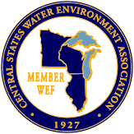
CENTRAL STATES
WATER ENVIRONMENT ASSOCIATION
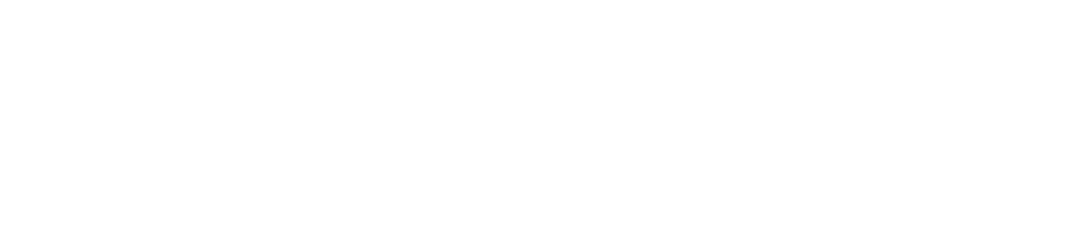
2025 Government Affairs Seminar
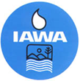
Held jointly with IAWA Mini Conference
March 12, 2025 9am-11:30am
President Abraham Lincoln Springfield Double Tree Hotel Springfield, IL
Registration Fee: $70
Meet and Greet Reception
Tuesday, March 11, 2025 6pm-8pm
Presidential Abraham Lincoln Hotel – Lincoln Room
AGENDA
9:00am – 9:05am Welcome and Introductions
Mark Gockowski
CSWEA IL Section Government Affairs Co-Chair

9:05am – 9:35am WEF Government Affairs Update
Steve Dye
Managing Director, Government Affairs & Strategic Partnerships, WEF

9:35am – 10:05am Workforce Development
Sheela Veme
Waubonsee Community College

10:05am – 10:20am Sponsor Highlight/Break

10:20am – 10:50am BABA Compliance
USEPA

10:50am – 11:20am Water Pollution Control Loan Program
Nidhan Singh, Manager
Infrastructure Financial Assistance Section, IEPA

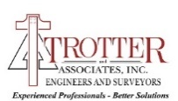
SPONSORS
